**TC USER GUIDE DOCUMENT**

**For**

**SONA FOODS**

Date: **Dec 2019**

Author: **ASHVINI BADHE**

**DOCUMENT HISTORY**

| **Revision** | **Date** | **Created / Updated By** | **Description** | **Approved By** |
| --- | --- | --- | --- | --- |
| 1 | 05th Dec 2019 | Ashvini Badhe | First Draft | Ruturaj Purohit |
|  |  |  |  |  |

1. **Teamcenter login**

Double click on Teamcenter icon on desktop

Enter User ID and Password and click on “Login” button

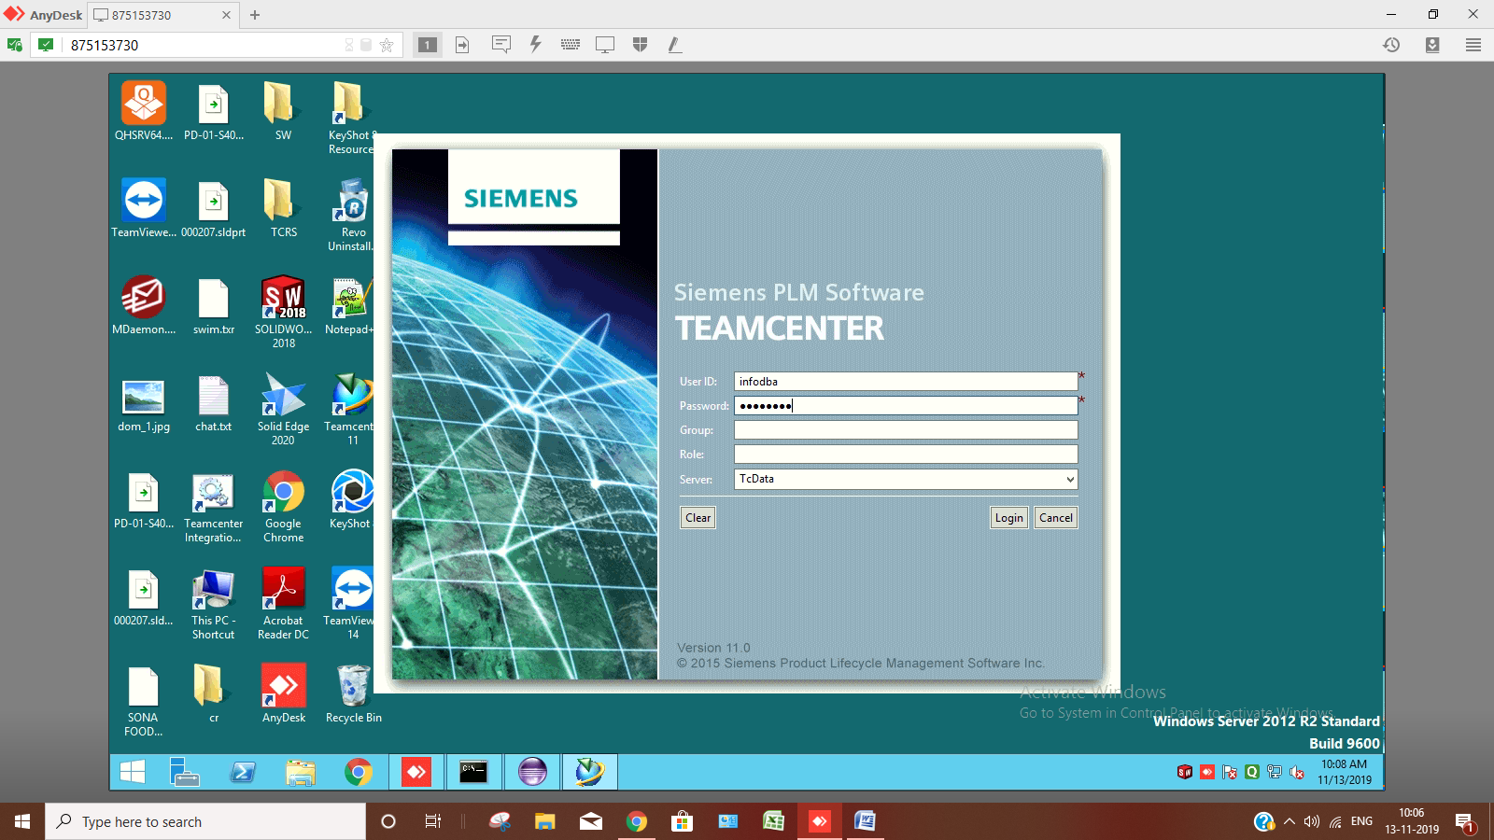

After successfully login to “My Teamcenter” application of Teamcenter will open

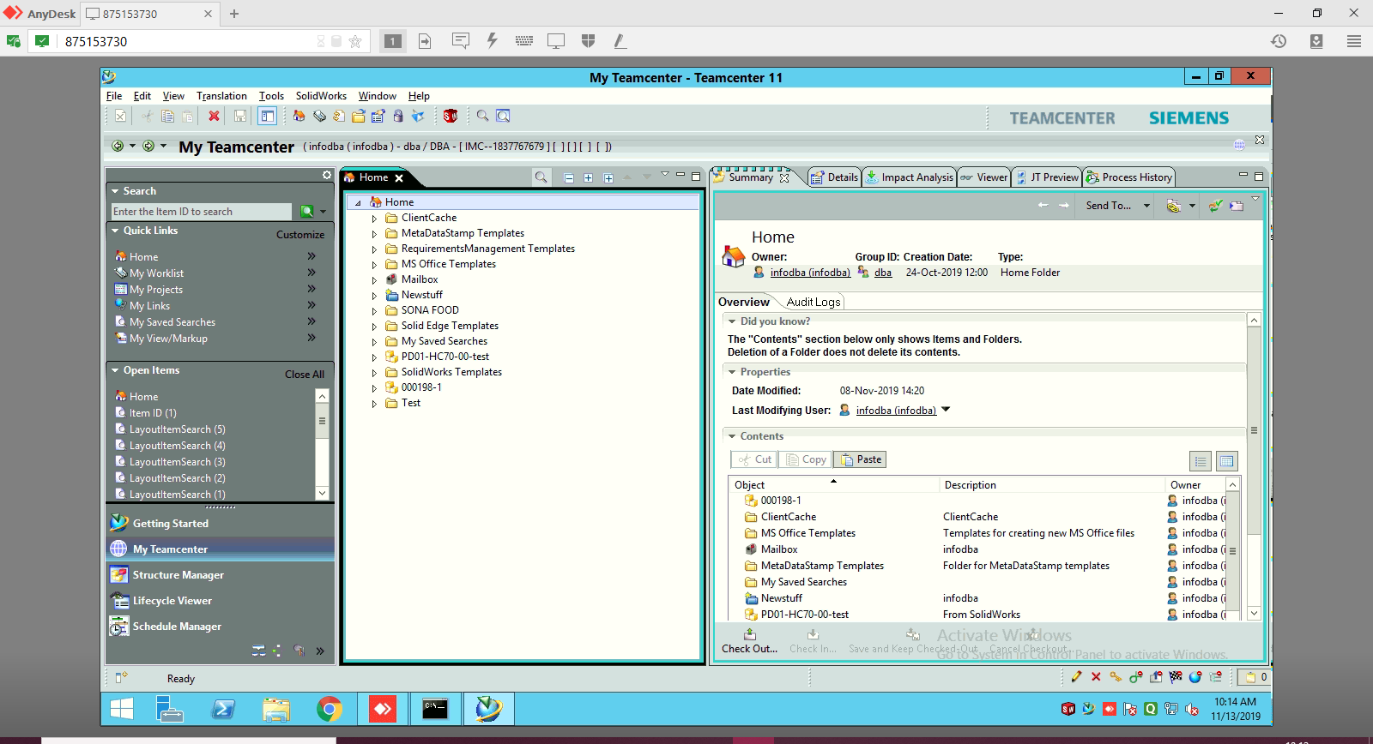

1. **Creation of new working directory**

Click on File 🡪 New 🡪Folder or Press Ctrl+Alt+F

Following panel will open.

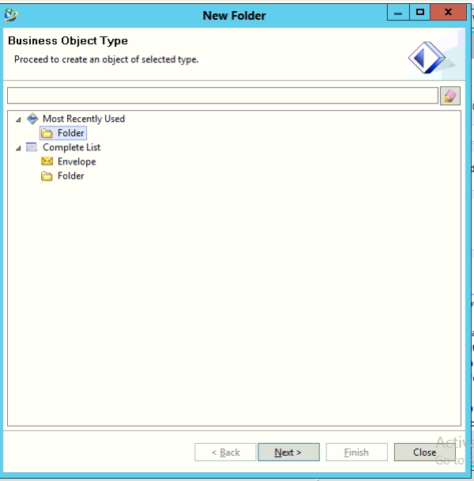

Select “Folder” as Business Object Type and Click on “Next” button

Following panel will open, fill the “Name” and click on “Finish”

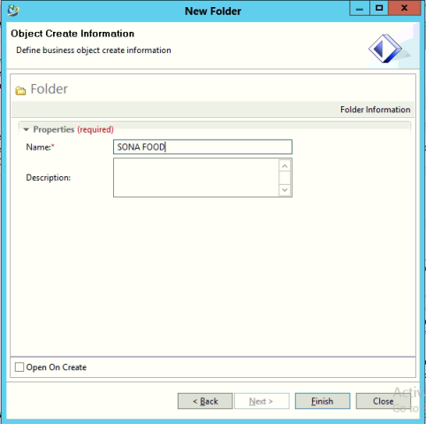

The folder will be created under “Home” folder.

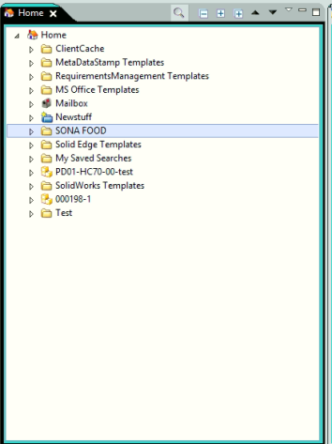

1. **Creation of Machine Design type item in Teamcenter**

Select the folder under which you want to create an Item

To create a new item, go to File 🡪 New 🡪 Item or press Ctrl+T

The following panel will open

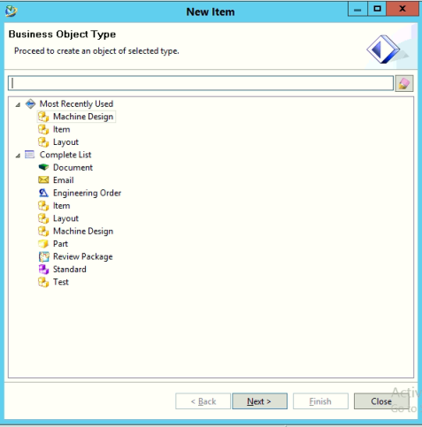

Select “Machine Design” as Object type and click on “Next” button

Following panel will be open

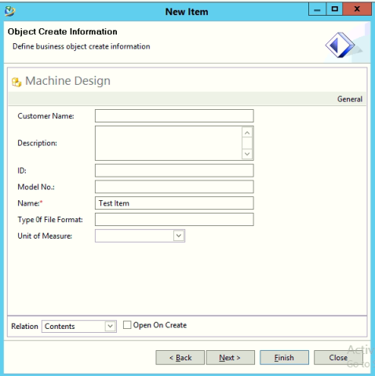

Enter the name of item and click on ”Next” button

The following panel will be open

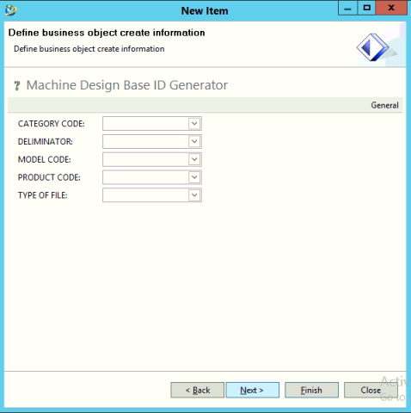

Fill the appropriate value

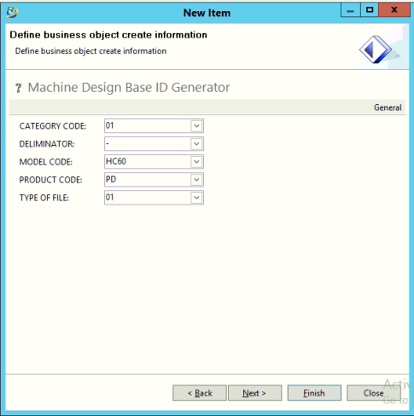

Click on “Finish” button

The item will be created under “SONA FOOD” folder

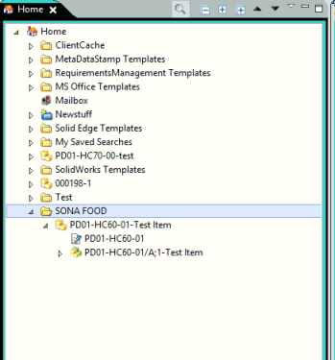

1. **Creation of Layout type item in Teamcenter**

Select the folder under which you want to create an Item

To create a new item, go to File 🡪 New 🡪 Item or press Ctrl+T

The following panel will be open

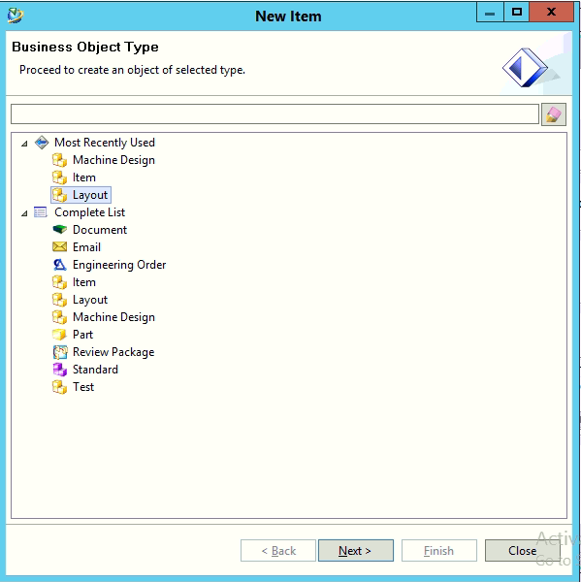

Select “Layout” as Object type and click on “Next” button

Following panel will be open

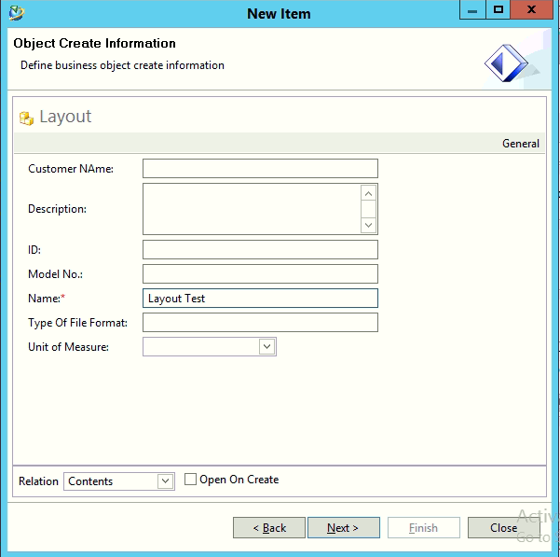

Enter the name of item and click on ***Next*** button

The following panel will be open

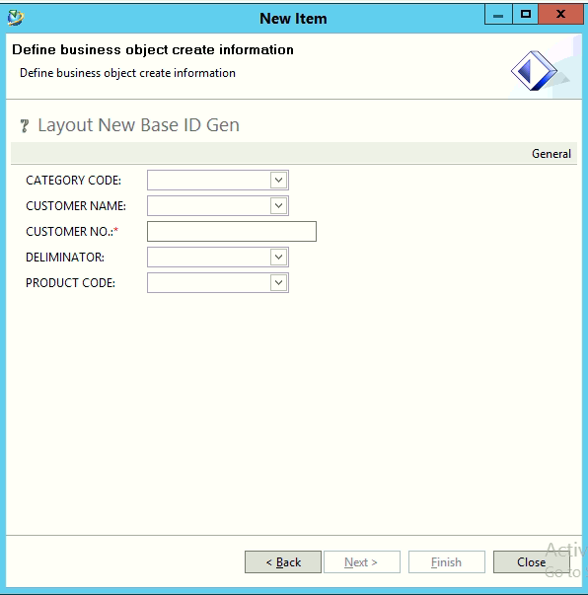

Fill the appropriate value

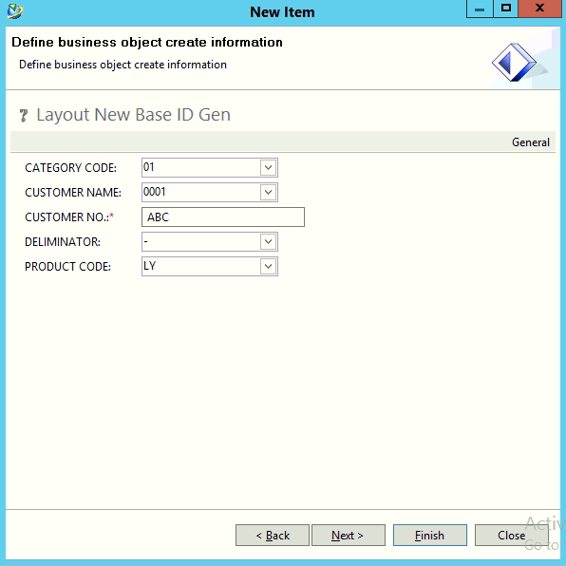

Click on “Finish” button

The item will be created under “SONA FOOD” folder

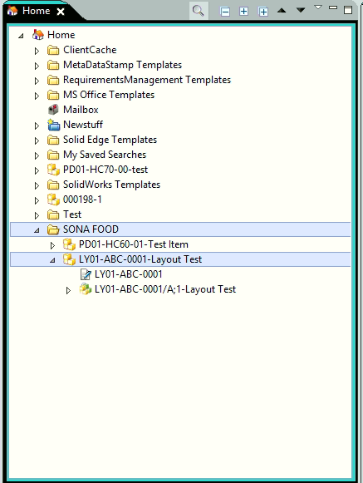

1. **Attach Dataset to the Item**

Select the revision which you want to attach the dataset

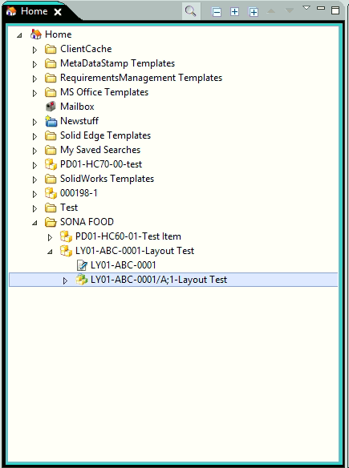

Go to ***File*** 🡪 ***New*** 🡪 ***Dataset*** or press ***Ctrl+D***

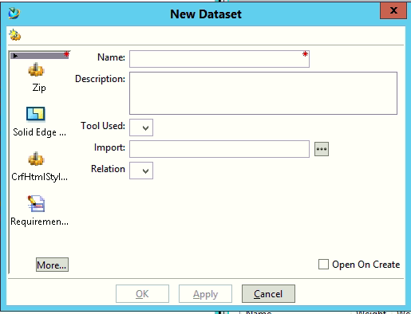

Click on “More” and select the particular dataset you want

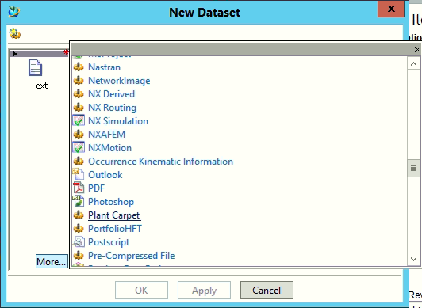

Click on ***PDF***

The following panel will open

Give the name to the dataset

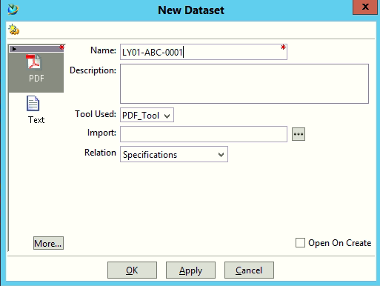

Click on “OK”

The dataset will be created as follows

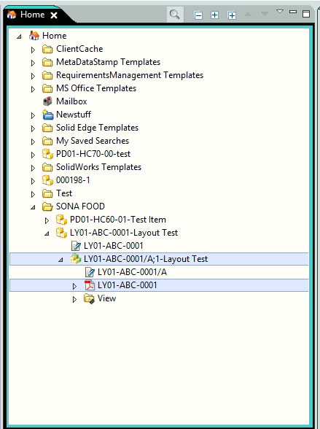

1. **Search for Item in Teamcenter**

In “Quick Search” search box enter the item id you want to search and click on the search icon

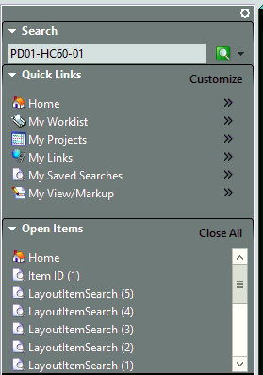

The result will be as follows

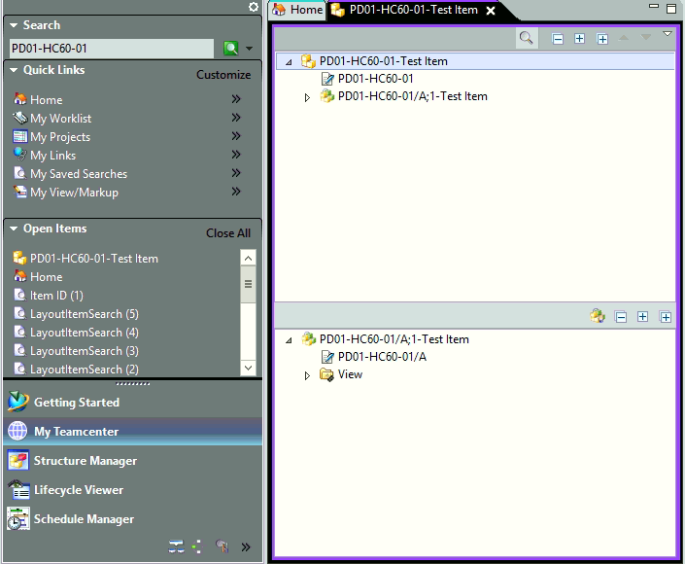

NOTE: The wild card entries are also allowed in search box (e.g PD*)

1. **Organization**

In “My Teamcenter” application click on the organization icon at the right side corner of bottom

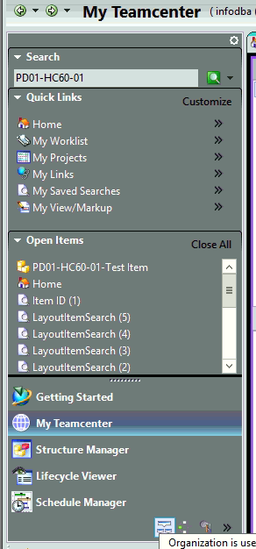

“Organization” application will be open

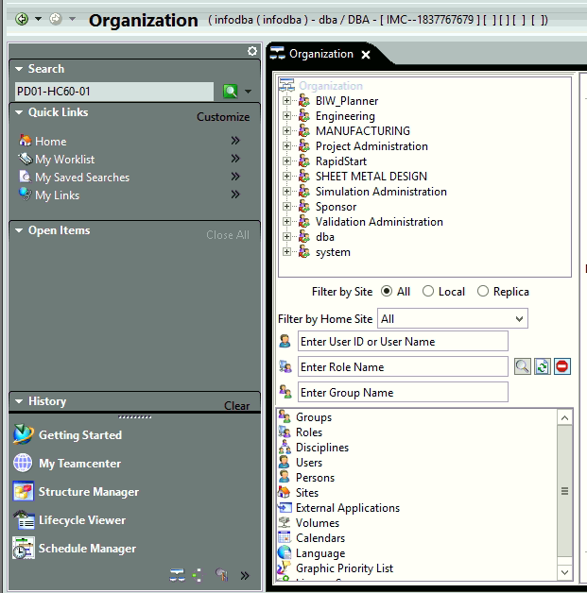

1. **Create group in Organization**

Click on the “Groups” in the Organization List Tree

Enter the Name of group and click on “Create” button

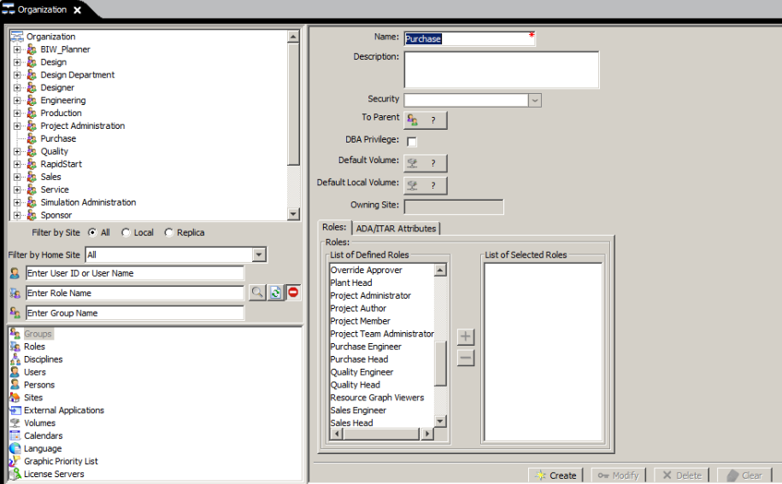

The group will be appear in organization tree

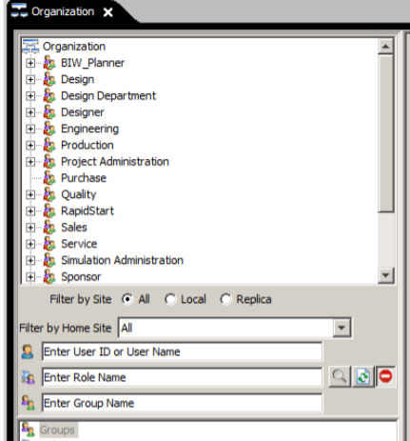

1. **Add existing role to specific group**

Click on the group under which you want to add new role

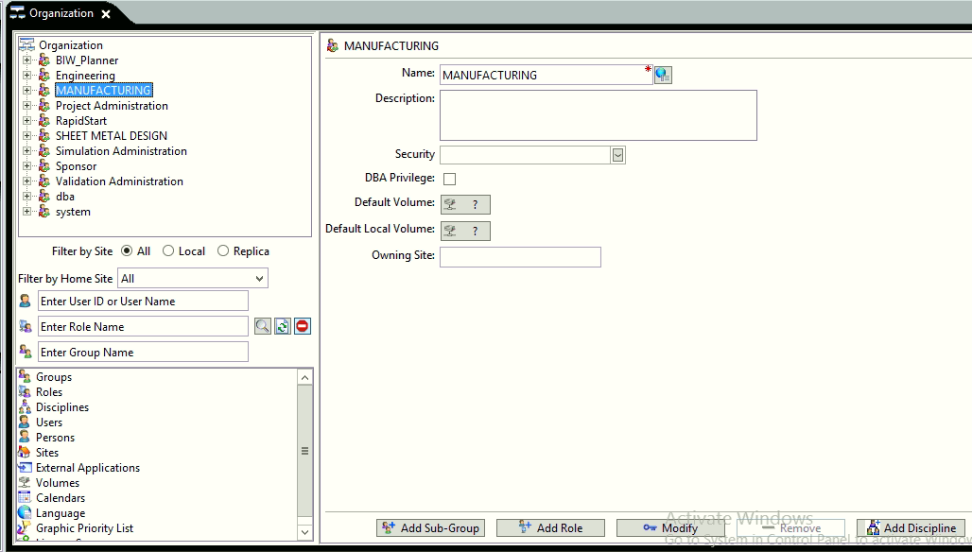

Click on “Add Role” button at the bottom

Following panel will be open

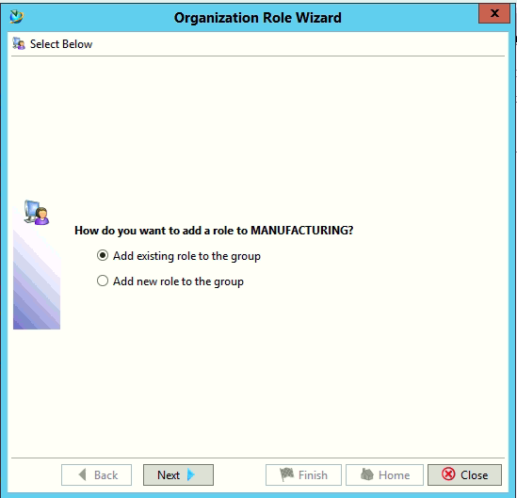

Select “Add existing role to the group” and click on “Next” button

Following panel will open

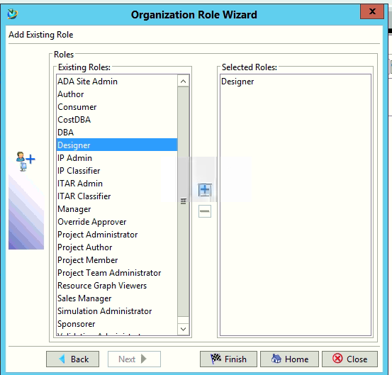

Add the particular role and click on “Finish”, the specific role will be add to that group

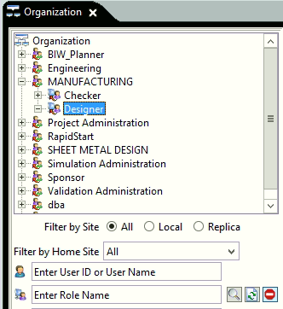

1. **Create new role under specific group**

Click on the group under which you want to create new role



Click on “Add Role” button at the bottom

Following panel will be open

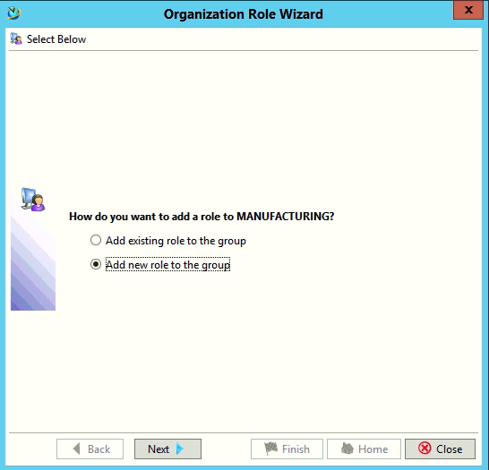

Click on “Next” button

Following panel will open

Enter the name of role which you want to create

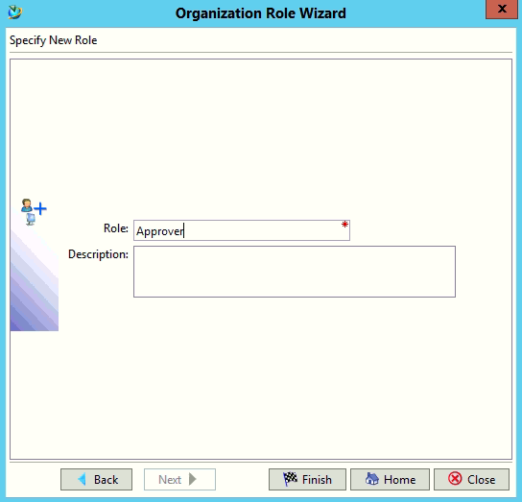

Click on “Finish” button, the role will be add to the particular group

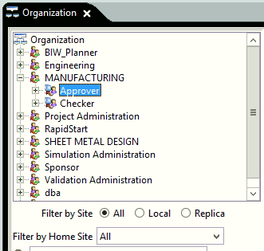

1. **Create new person in the organization**

Select “Person” from organization list tree

Fill the Name and other required data and click on “Create” button

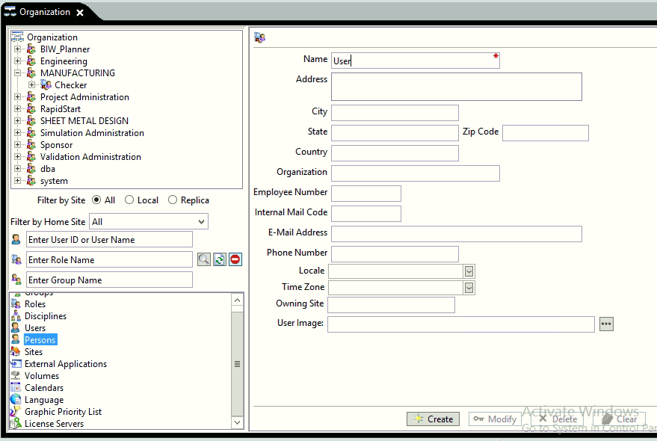

1. **Create new user in Organization**

Select “User” from organization list tree

Fill the Name and other required data and click on “Create” button

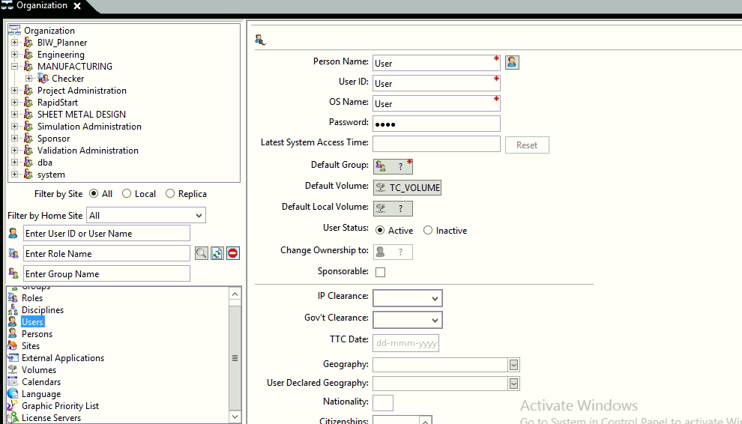

1. **Add existing user to the role**

Select the particular role to which you want to add user

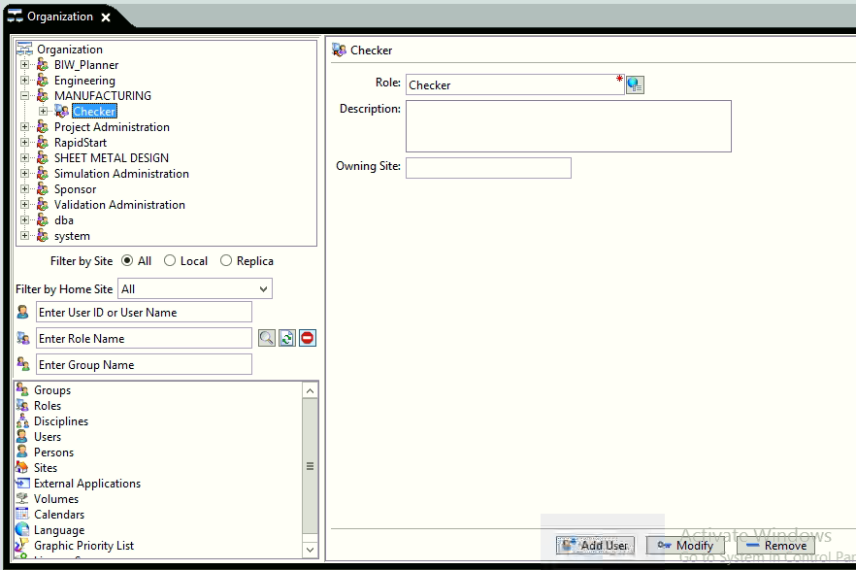

Click on “Add User” button

Following panel will be open

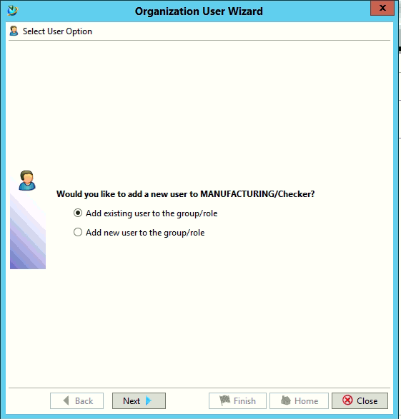

Select “Add existing user to the group/role” and click on “Next” button

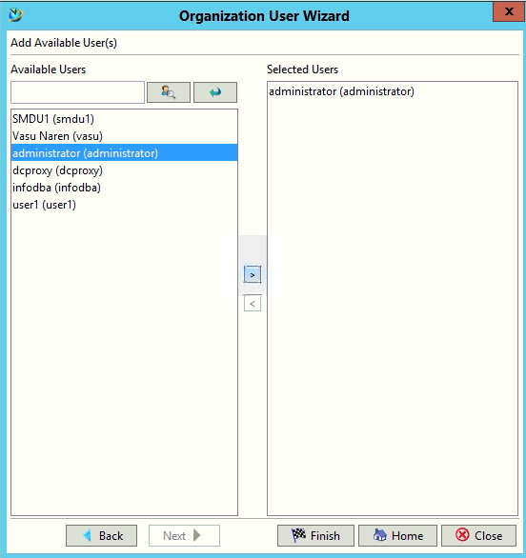

Click on “Finish” button, the user will be added t that particular role

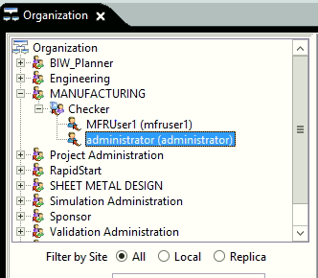

1. **Initiate workflow process**

Select the revision on which you want to initiate the workflow

Go to File 🡪New 🡪Workflow Process or press Ctrl+P

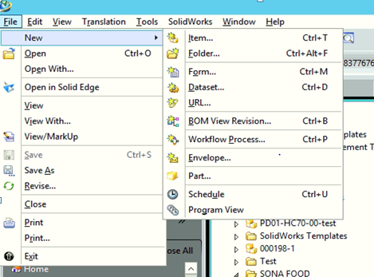

Following panel will be open, select the desire “Process Template”

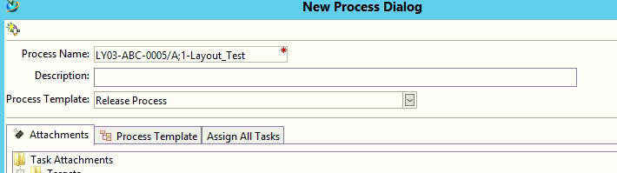

Click on ***Assign all Tasks*** and assign user to each task

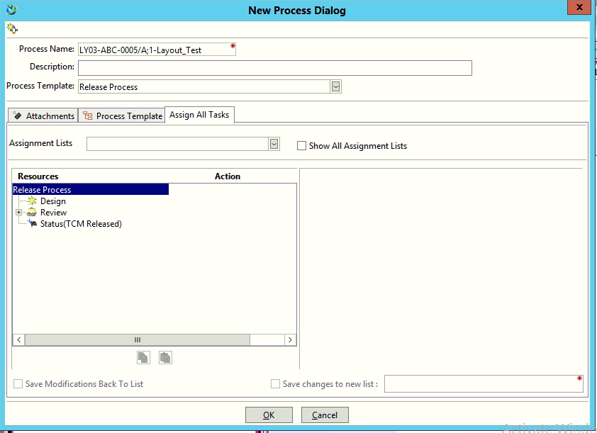

Click on ”OK” button and the process will be initiate on that revision and process icon will appear on revision

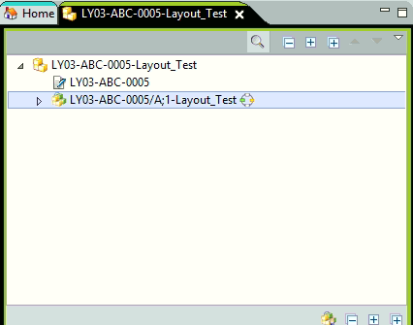

Right click on revision => Send to =>Workflow Viewer

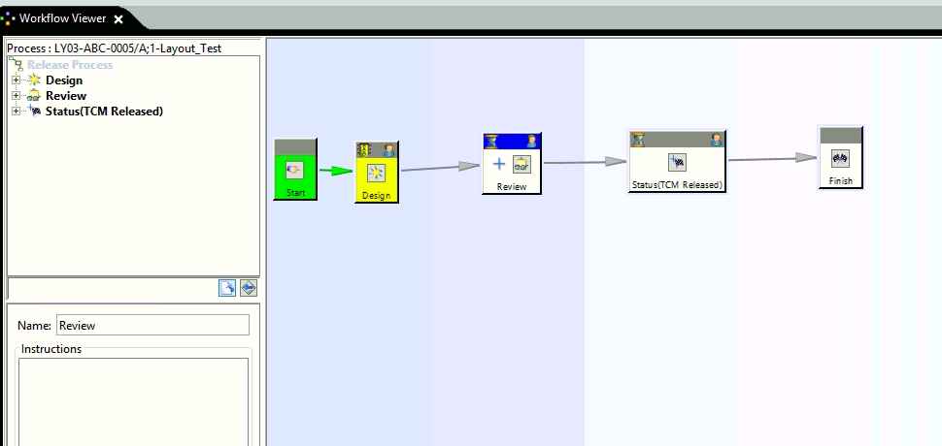

Select the “Design” task to perform action, Select “Complete” and press “OK”

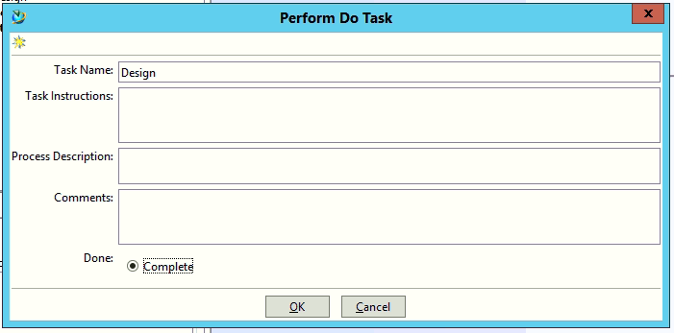

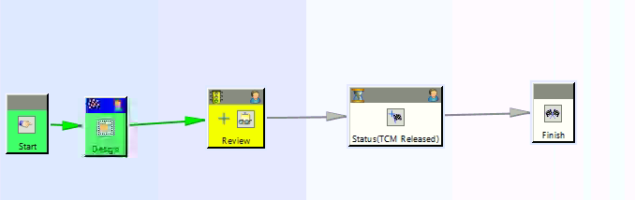

Review task is assign to the reviewer

Reviewer will see that task in his worklist

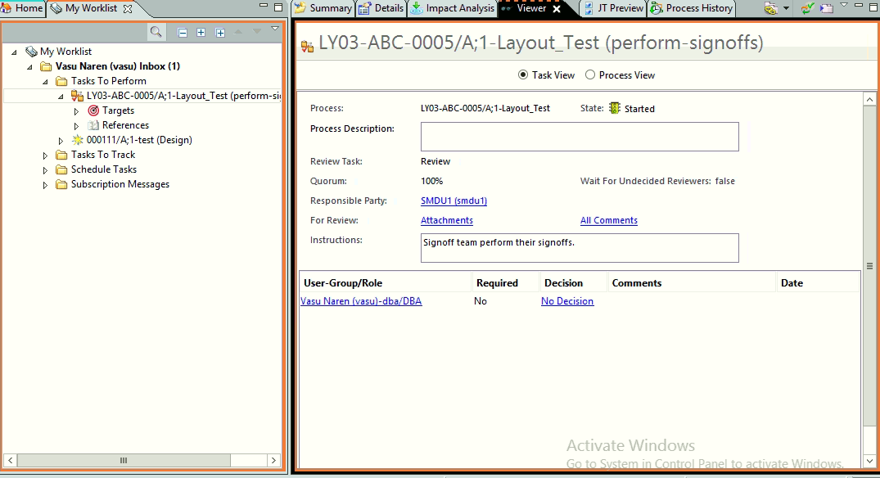

Click on “No Decision”

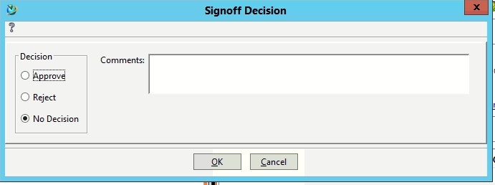

Give the “Signoff Decision” as Approve

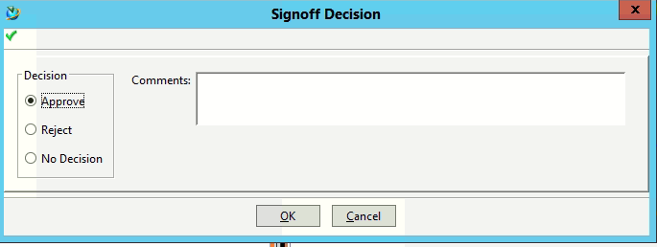

Click on “OK”

Status Flag will be appear on the revision

